|  |  |
| --- | --- |
|  | **LIBRARY MANAGEMENT SYSTEM**  **Technical Design Document** |
| |  |  |  |  | | --- | --- | --- | --- | |  | **Prepared By / Last Updated By** | **Reviewed By** | **Approved By** | | **Name** | Paras Saini |  |  | | **Role** | Project Developer |  |  | | **Signature** | Paras |  |  | | **Date** |  |  |  | |
|  |

Table of Contents

1.0 Introduction 3

1.1 Purpose of this document 3

1.2 Project overview 3

2.0 Solution Summary 3

2.1 Scope 3

2.2 Assumptions 3

2.3 Dependencies 3

2.4 Risks 3

3.0 Schematic Diagram 3

4.0 System Design 4

4.1 Proposed design 4

4.2 Component inventory 4

5.0 Database Design 4

5.1 Data Model 4

5.2 Tables Structure 4

6.0 Appendices 4

6.1 Glossary 4

6.2 Other 5

7.0 Terms & Conditions 5

8.0 Change Log 5

# Introduction

## Purpose of this document

The purpose of this document is to document the technical design, component details and Database design. This will also capture the scope, assumptions, risk, dependencies of this project.

## Project overview

A library management system is a software application that is designed to manage the operations of a library. The system provide an easy way to manage the task of librarian and help reader to access the library sources in the comfortable manner. This project free the librarian and reader from manual process of managing the record of available book, issued book etc. It overall improve the way in which we can explore and excess the library.

# Solution Summary

## Scope

This project has larger scope in simplifying the hectic management of library resources to compatible, easy and better handling of library resources. It helps librarian to manage the copies of book available, easily checkout process for book readers, easy renewal process etc.

* Library Book can be easily searchable and easy to find.
* Easy process of book checkout and renewing of book for more days.
* A reader can easily review the book which can help other reader to find best book for themselves through having other readers reviews about the book.
* Easy process of posting their doubts for clarification or reader can easily post their questions with the help of their mail.
* Readers can easily pay the amount or late fines of their book charges easily by having online payment integrated functionality.
* History page also available for readers which help them to get their overall history of which book they have checked out, due dates and all charges and any late fine.
* The system will provide admin operation to librarian through admin role a librarian can easily manage books like he can add, delete, increase or decrease the book quantity and set the availability of the book.
* Librarian as an admin role can easily clarify queries of readers who have posted through message.

## Assumptions

1. **Resources Assumption.**

The resources assumption of a library management system includes the availability and allocation of resources required for the development, implementation, and maintenance of the system. It may include hardware, software, staffing and support.

1. **Technology Assumption.**

Technology-based assumptions create a framework of the tech infrastructure required to meet project goals. Technology resources may include Operating system, network infrastructure, database management system, mobile technologies and more. Tech is usually internal but could be outsourced, so it's important to be very aware that the reliability of any outsourced resources could be affected by the availability, capabilities and procedural difficulties that could occur. Identifying these possible constraints allows you to prepare a contingency plan in case any of these problems occur internally as well.

1. **Time-Based Assumption**.

These potential limitations, also known as scheduling assumptions, are often affected by the availability of critical resources like technology, project members. Again, it's recommended that we have built-in contingencies to buffer any lack of resources that can significantly impact on our project timeline.

1. **Quality /Specification Assumption**.

Quality assumptions can impact a project schedule if the standard of quality is lacking, causing the work to need to be redone. Safety guidelines play a role, too, when your team is required to adhere to certain specifications, in which there is no room for error and any small divergence from specifications can impede the success of the project.

1. **Local / Environment Assumption.**

These assumptions involve the location in which the work will take place and the environmental conditions under which it's performed. A project can be negatively affected if incorrect assumptions are relied upon and the projected location changes. Assumptions play an essential role in developing a risk management plan. The project should be completed successfully, on time.

## Dependencies

## Front-end development frameworks: React is used for frontend.

## Back-end development frameworks: SpringBoot is used for backend.

## Database management systems: MySQL is used for databases.

## Risks

* **Technical Risks:** Technical risks associated with the development, implementation, and maintenance of the library management system include system downtime, software bugs, and hardware failures.
* **Change Management risk:** The implementation of a new library management system may require changes in organizational policies and procedures, leading to resistance and confusion among library staff. To mitigate this risk, change management strategies and communication plans must be developed.
* **Data Security risks:** The library management system may contain sensitive information about library users, payment information, personal information of user and resources, making it a potential target for cyberattacks or data breaches. To mitigate this risk, appropriate security measures like we add okta for security measure and such as encryption, firewalls, and user access controls must be implemented.

# Schematic Diagram

This diagram shows the view of full stack application architecture, how a fullstack application works, how is call the backend from the frontend and how backend fetch the data from the database.

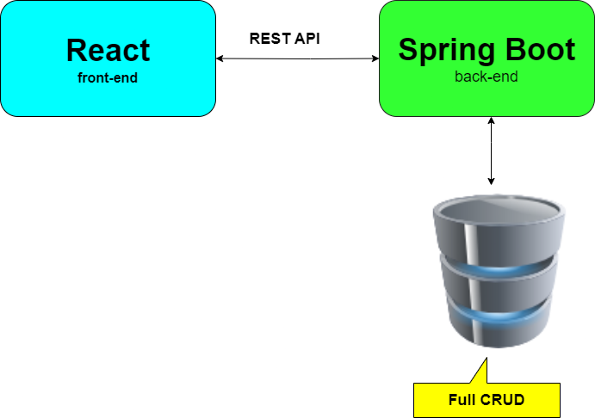

Fig1.1 FullSatck Application Architecture

# System Design

## Proposed design

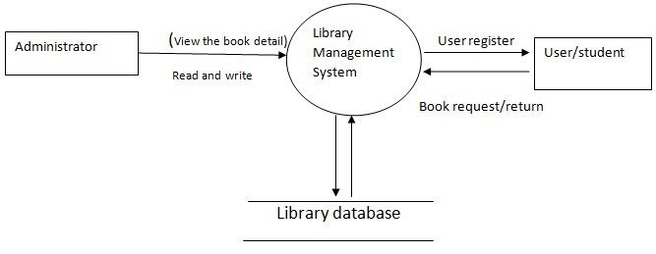

Fig.1.2 Library Management System Design

## Component inventory

*The components of the project will be,*

* *Librarian*
* *Reader*

# Database Design

## Data Model

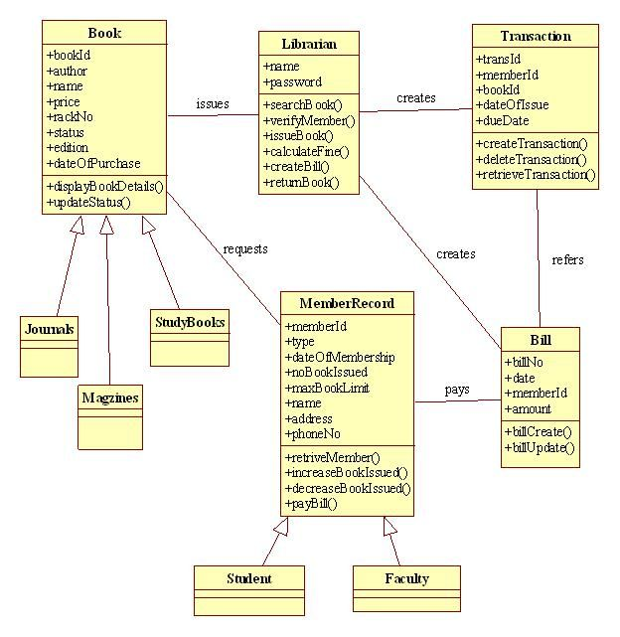

## Tables Structure

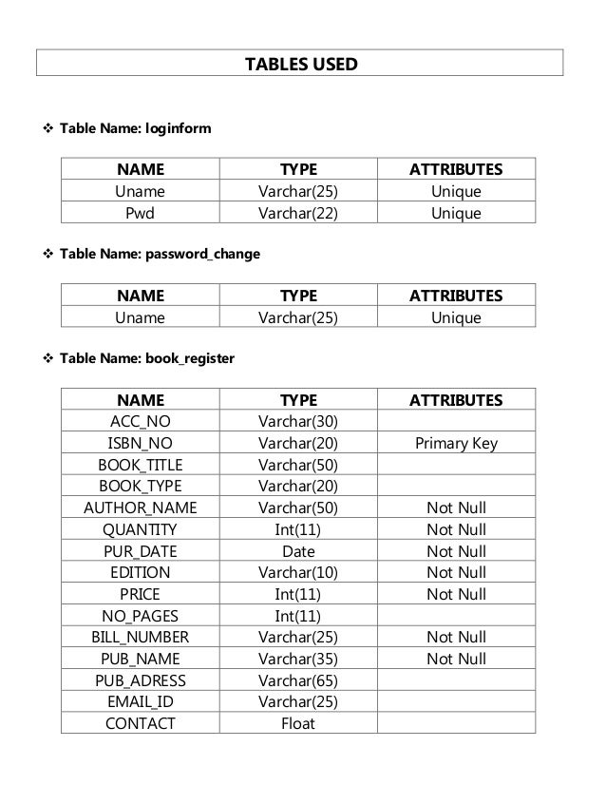

# Appendices

## Glossary

|  |  |
| --- | --- |
| **Acronyms** | **Definitions** |
|  |  |

## Other

# Terms & Conditions

***Disclaimer: Please do not circulate or distribute this document outside of Cognizant Network, We have a Zero Tolerance Policy. Kindly adhere to 100% Compliance at all times.***

# Change Log

*Please note that this table needs to be maintained even if a Configuration Management tool is used.*

|  |  |  |  |  |
| --- | --- | --- | --- | --- |
| Version Number | Changes made | | | |
| V<n.n> | *<If the change details are not explicitly documented in the table below, reference should be provided here>* | | | |
| Page no | Changed by | Effective date | Changes effected |
|  |  |  |  |
|  |  |  |  |
|  |  |  |  |
|  |  |  |  |